**Project Based Learning-II**

Work Book

### Course Code: 210258

**(2019 Course)**

## Second Year Engineering

Year 2020 - 2021, Sem II

Group ID:

|  |  |  |  |
| --- | --- | --- | --- |
| B | - | 0 | 6 |

Team Members: Name of Student Roll No.

1. Sujal Joshi COMPSEB1405
2. Pushpak Veer COMPSEB1402
3. Tejas Thorat COMPSEB1309
4. Sarang Phalak COMPSEB1364
5. Akshay Wagh COMPSEB1325
6. Subodh Jadhav COMPSEB1332 Project Title : Building A Basic Browser using Python

Name of Guide : Prof. D.A. Phalke Mam

**CERTIFICATE**

This is to certify that **Mr. Sujal Joshi , Mr. Pushpak Veer , Mr. Tejas Thorat , Mr. Sarang Phalak , Mr. Akshay Wagh , Mr. Subodh Jadhav**. Group No. **B06** Division **SE-B** Branch **Computer Engineering** has successfully completed the work associated with **Project Based Learning II (210258**) titled as **Building a Basic Browser Using Python** and has submitted the work book associated under my supervision, in the partial fulfillment of Second Year Bachelor of Engineering(Choice Based Credit System) (2019 course) of Savitribai Phule Pune University.

Date: 28-04-2021

Place: Pune

Guide Head

Prof. D. A. Phalke Dr. Madhuri A. Potey

## Table of Contents

|  |  |  |
| --- | --- | --- |
| Sr. No | Chapters | Page No |
| 01 | Introduction | 1 |
| 02 | Motivation of Project | 2 |
| 03 | Problem Definition and Scope | 3-8 |
| i. Problem Statement | 3 |
| ii. Objectives | 3 |
| iii. Architecture | 4 |
| iii. Scope of the project | 8 |
| iv. Algorithms/Techniques | 8 |
| 04 | Hardware and Software Requirements | 9 |
| 05 | Flowchart/ DFD | 10 |
| 06 | Benefits to the Society | 11 |
| 07 | Results and Outcomes | 11 |
| 08 | Conclusion | 12 |
| 09 | Future scope | 12 |
| 10 | References | 12 |

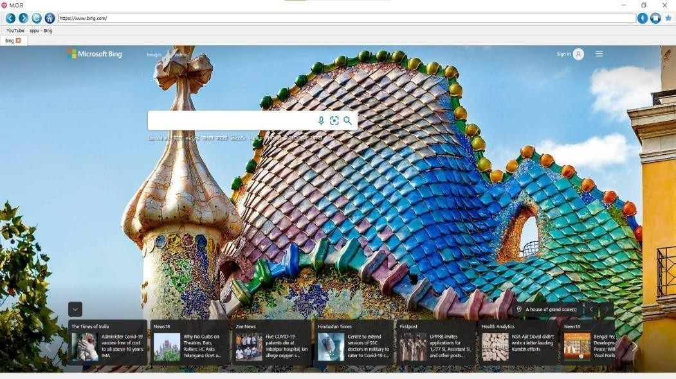

Building a Basic Browser by using Python

### Introduction

A web browser is a type of software that allows you to find and view websites on the Internet. Even if you didn't know it, you're using a web browser right now to read this page !

1. This is the a simple browser M.O.B
2. Made with Python language and its libraries.
3. We are using so many types of libraries.

The same features which are there in other browsers like Bookmark , Virtualassistant, Navigation buttons like Forward ,Backward ,Refresh and Homepage.

Internet. The most typical use of an Internet browser is to load and view websites on the Internet.

Internet browsers can also be used to view local files on a computer. For example, you can open text documents or highly formatted documents such as XML (Extensible Markup Language) or HTML (Hyper Text Markup Language) documents

### My Own Browser

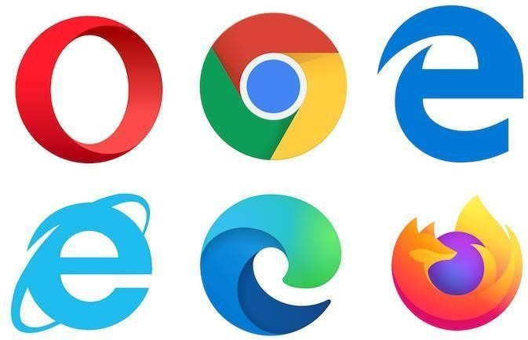

Building a Basic Browser by using Python

* 1. **Motivation of Project**

There are many popular browsers like Google Chrome ,Mozilla Firefox ,Opera mini ,Apple Safari etc. are available on internet .But many ofthem have privacy related issues and many times they are fined for processing information without users concern . Also there is not any popular Indian browser .To prevent such privacy related issues and third party activities we need one secure Indian browser .

We got to learn different concepts during making of thisproject .Using those concepts we tried to make our own secure basicbrowser.

Examples :

Building a Basic Browser by using Python

## Problem Definition and Scope

### Problem Statements.—

* 1. Creation Of Window View.
  2. Creation Of Navigation Bar.
  3. Creation Of Basic Button like back, forward, reload, home

,stopand adding search bar.

* 1. Adding Icon to Window and Buttons.
  2. Updating Url at search bar when actions like back , forward ,home ornew tab occured.
  3. Creation Of Bookmark Button and adding to navigation bar.
  4. New Navigation Bar below existing and displayingbookmarked sites.
  5. Creation Of tabbed Window below the displayed bookmark and Make them closable other than last or single tab.
  6. Creation Of Virtual Assistant and adding it to navigation bar with multiple commands like play song, search a site ,etc.

### Objectives --

* 1. Making User Friendly by adding Basic Button forCommon Commands.
  2. User can search any site just by copy-pasting or typing it in search baron navigation bar.
  3. Adding Bookmark and displaying in front of user at same time for quick access.
  4. User Can Open And Close multiple tabs as per requirements. 5.Addition of Advanced feature of Virtual Assistant to help user to

Search songs and sites just by voice commands.

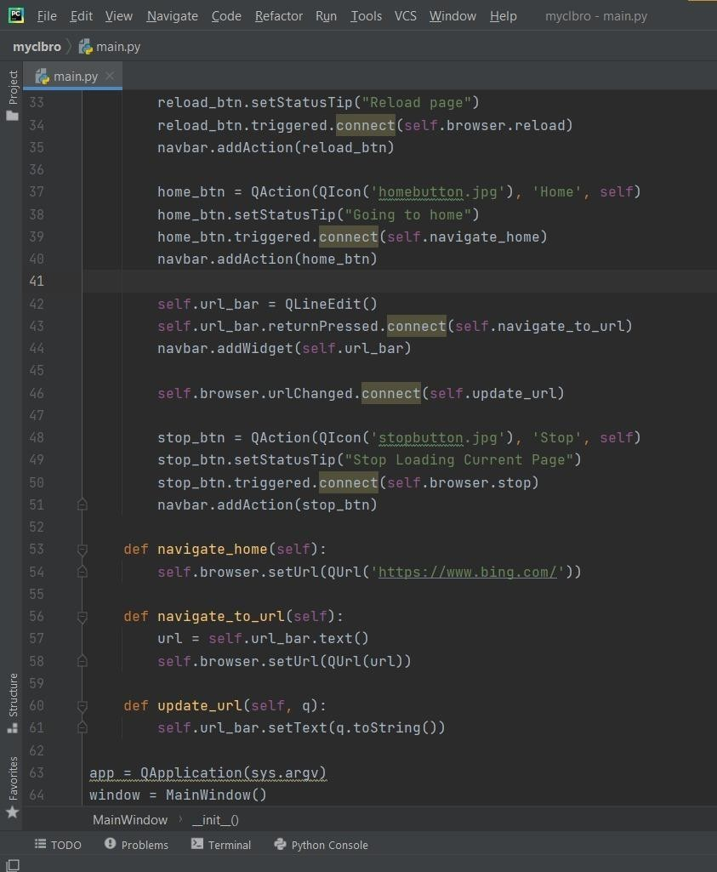

Building a Basic Browser by using Python

### Architecture --

* 1. Creation and Addition Of Logo of Browser and Buttons to identify easily.
  2. Adding Navigation Bar at top and back-forward Button in left side of bar. 3.After them here comes the home and reload buttons before the

search bar. Then Favourite-Bookmark Button just after search bar soit can be accessed easily. Here it your Virtual Assistant after the Bookmark and before the last Stop button to support user.

1. Another navigation bar below existing to show bookmarked sites and foreasy access for user.
2. Last but not least Tabs which are editable after all navigation requirements.

Building a Basic Browser using Python

**Adding Functionality to Navbar Tools**

**= Home Button**

**= Forward Button**

**= Back Button**

**= Reload Button**

**= Stop Button**

Building a Basic Browser by using Python

### Scope Of Project --

* 1. Virtual Assistant would increase increase the speed of browsing url site just by commanding to it.
  2. We will be able to search any url on our browser and perform basic commands.
  3. We will be able to add our favourite sites so that they can be accessed easily and quickly.
  4. We will not remained depended on other browser's.

### Module 1

* Created Browser View
* Default search engine as Bing
* Navigation Tools

### Module 2

* Adding Functionality to Navbar tools

### Module 3

* Bookmark Tool

Bookmark your favourite tabs using this tool.

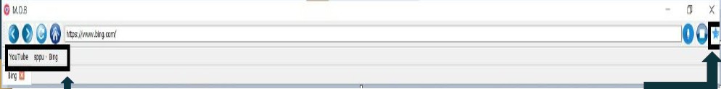

A bookmark is a saved shortcut that directs your browser to a specific [webpage](https://techterms.com/definition/webpage). It stores the

title, [URL](https://techterms.com/definition/url), and [favicon](https://techterms.com/definition/favicon) of the corresponding page. Saving bookmarks allows you to easily access your favorite locations on the Web.

Building a Basic Browser using Python

### Module 4

* Adding Tabs

We can Open multiple tabs at same time.

### Module 5

* Voice Search

Browser can search using speech to txt conversion



Voice search, also called voice-enabled, allows the user to use a voice command to search the Internet, a website, or an app.

In a broader definition, voice search includes open-domain keyword query on any information on the Internet, for example in Google Voice Search, Cortana, Siri and Amazon Echo.



Building a Basic Browser using Python

### Algorithms/Techniques --

1. Start.
2. Add all required libraries and import system.
3. Make a class for bookmark for performing operation of bookmark.
4. Make another class of MainWindow and create constructor so system canwork on itself.
5. Create Tabs using QTabWidgets and make it Central Widget with some functions to make it closable and adding new tab .
6. Create Navigation Bar to Window and create button for the multiple functionality like back, forward, home, reload, searchbar, Virtual Assistant , Favourite and stop.
7. Add logo's to button and Icon to Window as a trademark
8. Make some functions of bookmark button to call class bookmark and savesettings when window closed.
9. Make’s one functions to perform operations when Virtual

Assistant iscalled.

1. Complete the functions required to Change Url on search bar , complete actions when home button is called.
2. Set Cursor Position to 0 so that system can run properly on current tab.
3. Make Window visible and set application name so that settings can besaved by it.
4. Add sys.exit(app.exec_()) so app executes properly and window closable when exit is clicked.
5. 14. Exit

Building a Basic Browser by using Python

## Hardware and Software Requirement

**Hardware :**

RAM :4 GB

Processor : minimum 1 GHz

Operating system : windows 7 or newer

## Software :

Pycharm IDE NSIS Installer

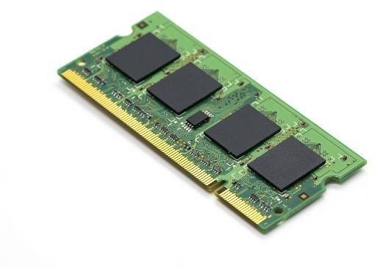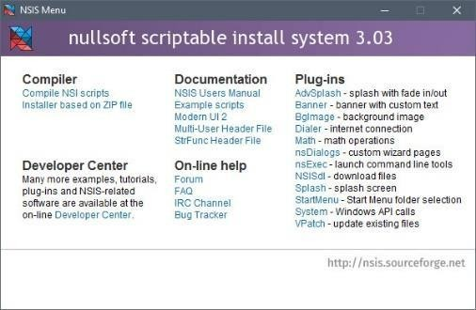

Building a Basic Browser by using Python

**5 Flowchart/DFD**

**Start**

**Main Window**

**Set Cursor Position 0**

**Sys.Exit()**

**Tabs**

**Back page If available**

**Go Back**

**Back**

**Current Tab**

**New tab**

**Front page If**

**Go front**

**Forward**

**available**

**Close app**



**Home**

**Default URL**

**Reload**

**Reload Current**

**Search url**

**Return url site**

**Stop**

**Stop loading**

**Play song**

**Search Url**

**If bookmark not in**

**Set Cursor Position 0**

**Favourite**

**Add Bookmark at Navigation Bar**

**V.A**

**Search On**

**bookmark**

**list**

**Stop**

Building a Basic Browser by using Python

## Benefits to the Society

The M.O.B has a basic user interface with mostly used buttons like forward, backward, refresh, etc. It also has a search bar or Omnibox, which helps usersto search the web address. Many websites are created with advanced scripting, which may be the source of sluggish navigation.

M.O.B is a clean and simple browser. M.O.B is designed to be the web browser. With one click, it loads web pages, multiple tabs, and applications.

It is inspired by the movement of Atmanirbhar Bharat and as an Indian, we learned built a basic version of browser

* + 1. **Result And Outcomes**

We built a basic browser with some advance features by using single language python

Building a Basic Browser by using Python

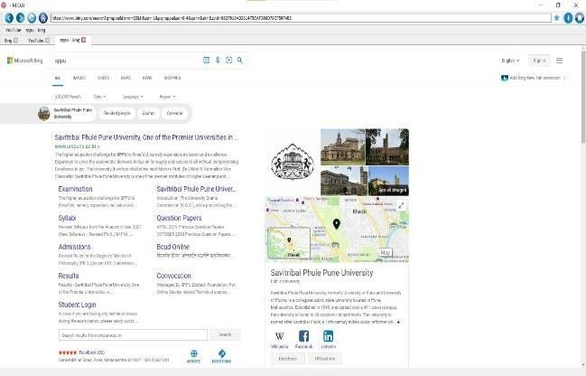

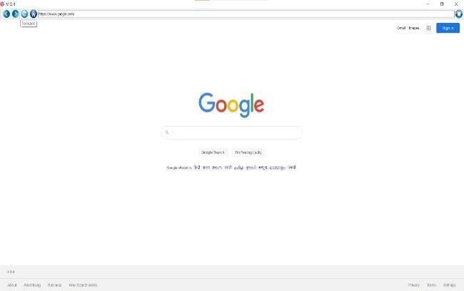

Building a Basic Browser by using Python

## Conclusion

Now a days most of the people are concerened about there privacy and data in this modern era so we want our own apps softwares and not to rely on others so that they could make use of it.

MOB browser is the same initiative that we want our own browser and reduce our dependencies on the other foreign apps and software so we have this our first step in creating it with basic features that every browser has.

We can create new tabs bookmark it navigate through the pages and also with speech search we have made it more user friendly ..

## Future Scope

In the era of ubiquitous internet that we are going to experience very soon,

we want the browser to be literally available

everywhere - be it

on the fridge or the dining table or may be on the wall too

Building a Basic Browser by using Python

**10 . Reference**

# Mozzarella Ashbadger

* + Online learning Platform

# Real Python

* + Real Python Team *(Real Python, 2017)*

1. Qt for Python